Spring boot Testing

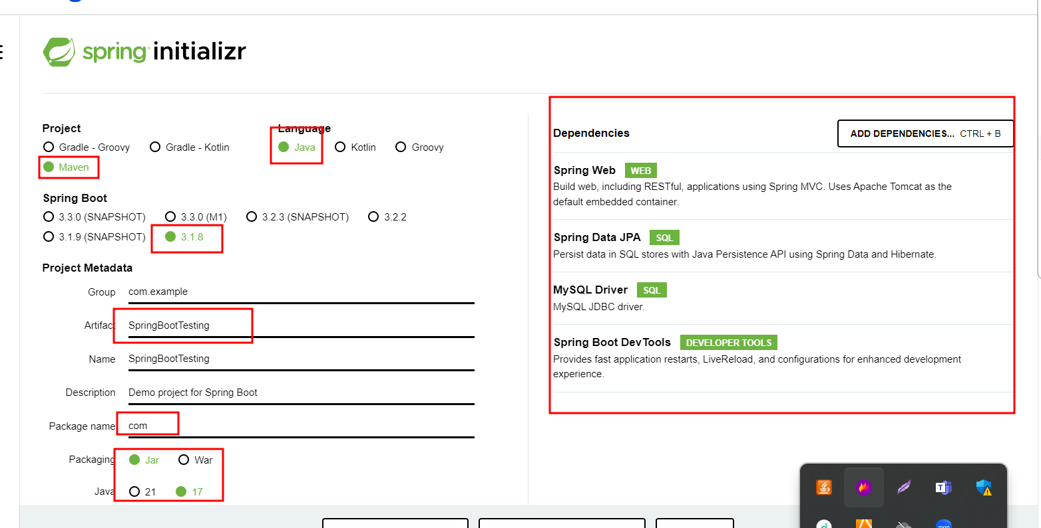

If we want to do the testing for controller

Controller depends upon service

Service depends upon dao or repository

Dao or repository depends upon database. With table and records.

Controller want to do mock for service layer.

A B 1500 Rs

A C

A D

B C

B D

Project 1

Eureka Server 🡪 8761

Starter : Eureka and Web Starter

Book cab micro service-🡪 8181

Web Starter @controller view can be thymeleaf or jsp

Thymeleaf

Eureka Client

JPA Starter

Mysql starter

Dev tools

Booking table

Bid Name DateAndTime Fare etc

Book cab micro service going to communicate fare micro service to get the fake base upon A to B distance.

View

As JSP or Thymeleaf then @Controller

View as

Angular then @RestController

<https://start.spring.io/>

Project 1

Eureka Server 🡪 8761

Starter : Eureka and Web Starter

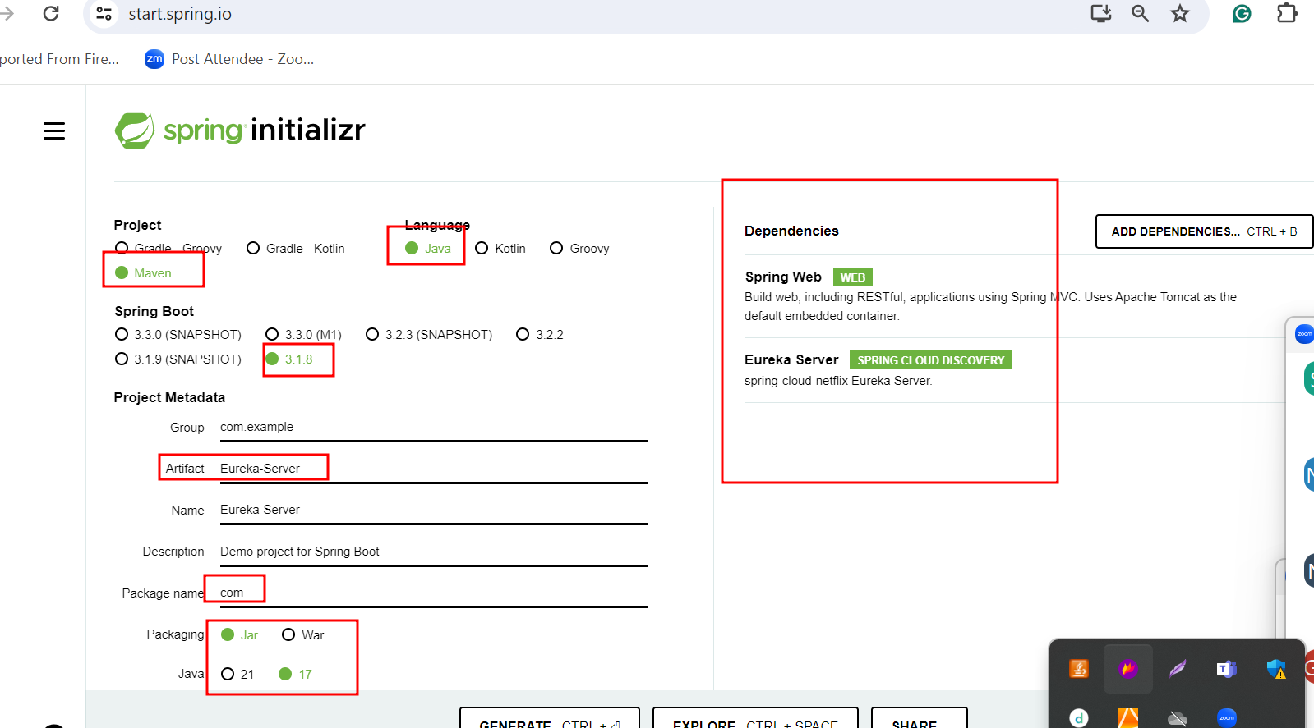

In application.properties file

server.port=8761

eureka.client.register-with-eureka=false

eureka.client.fetch-registry=false

Main class

package com;

import org.springframework.boot.SpringApplication;

import org.springframework.boot.autoconfigure.SpringBootApplication;

import org.springframework.cloud.netflix.eureka.server.EnableEurekaServer;

@SpringBootApplication

@EnableEurekaServer

public class EurekaServerApplication {

public static void main(String[] args) {

SpringApplication.run(EurekaServerApplication.class, args);

System.err.println("Eureka Server up on port number 8761");

}

}

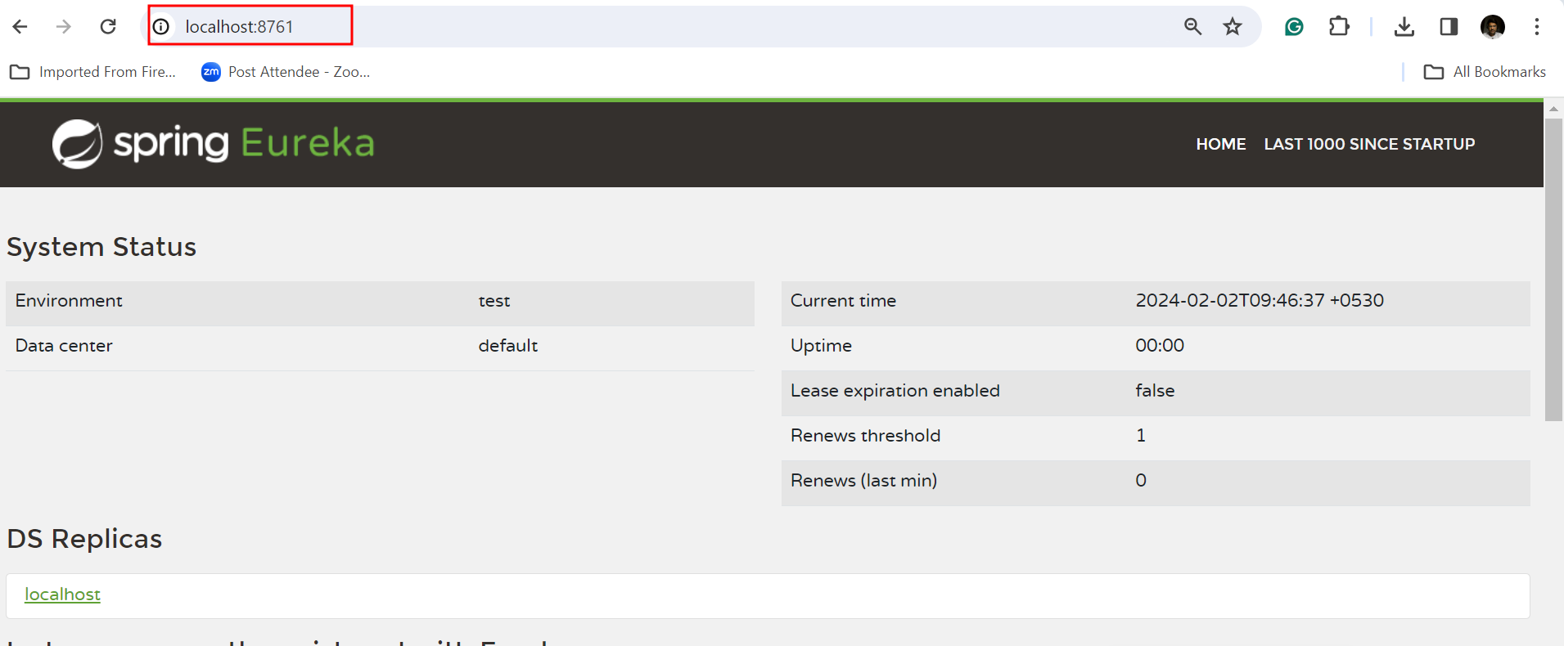

Book cab micro service-🡪 8181

Web Starter @controller view can be thymeleaf or jsp

Thymeleaf

Eureka Client

JPA Starter

Mysql starter

Dev tools

Booking table

Bid Name DateAndTime Fare etc

Book cab micro service going to communicate fare micro service to get the fake base upon A to B distance.

­Calculate fake micro service -🡪 8282

Web Starter @rest controller

Eureka Client

JPA Starter

Mysql starter

Dev tools

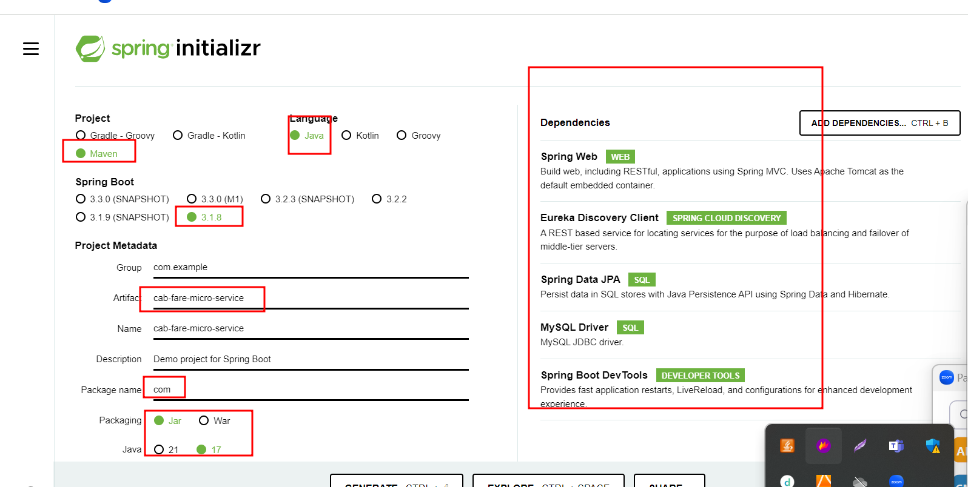

application.properties

server.port=8282

spring.application.name=cab-fare-micro-service

spring.datasource.driver-class-name=com.mysql.cj.jdbc.Driver

spring.datasource.url=jdbc:mysql://localhost:3306/cab_fare

spring.datasource.username=root

spring.datasource.password=root@123

spring.jpa.hibernate.ddl-auto=update

Cab Fare

Table

From To type of Cab fare

A B Innova 8000

A B swift 6500